The Twelfth SDPS Transdisciplinary Conference - Workshop on Integrated Systems, Design & Process Science was recently hosted by the AUM Informatics Institute November 1-5, 2009. The theme was Informatics & Cyberspace: Transdisciplinary Research and Education, download complete program. Informatics experts from around the globe came to AUM.
Speakers
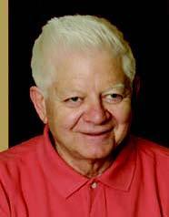Oktay Sinanoglu, Yale University
Oktay Sinanoglu has been nominated twice for Nobel Prize. A Turkish scientist of theoretical chemistry and molecular biology, he is the youngest person in 20th century to be named a full professor at Yale University. In 1962, he solved a mathematical theorem that had been unsolved for 50 years when he theorized the “Many-Electron Theory of Atoms and Molecules.” He has two lifelong chairs at Yale in molecular biology and was the first to earn the Alexander von Humboldt Science Prize. In 1975, he was named Japan’s International Outstanding Scientist.

David Gibson, IC² Institute
David Gibson earned his Ph.D. is from Stanford University with an emphasis in organizations, communication theory and innovation. He is a founding advisor to SDPS and, in 2000-01, he was a Fulbright Scholar at Insituto Superior Tecnico, Lisbon, Portugal. He teaches knowledge/technology transfer and adoption in IC²’s MSSTC degree program. He is director of UT-Austin/Portugal International Collaboratory for Emerging Technologies (CoLab) and University Technology Enterprise Network (UTEN). His research and publications focus on management of technology/knowledge, cross-cultural communication and management, and the growth and impact of regional technology centers worldwide.
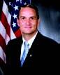Gregory L. Garcia, 754th Electronic Systems Group, U.S. Air Force
A member of the Senior Executive Service, Gregory L. Garcia heads the 754th Electronic Systems Group for the U.S. Air Force and based at Maxwell Air Force Base, Gunter Annex, in Montgomery, Ala. His organization is comprised of more than 1,700 military, civil service and contractor support personnel and has an annual budget exceeding $300 million. The group develops, acquires, sustains and operates worldwide communications-computer capabilities for the president, secretary of defense, Department of Defense, chairman of the Joint Chiefs of Staff and unified combatant commanders to direct military forces.
Stephen Goldsby, Integrated Computer Solutions, Inc.
Stephen Goldsby has been an information technology and security professional since 1991. In 1997, he created Integrated Computer Solutions, which has grown from one employee to nearly 100. The bulk of Goldsby’s experience is in the information technology and security industry as a subject matter expert and consultant to federal, state and commercial organizations spanning all major verticals.

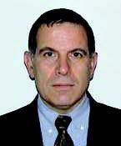Ibrahim Esat, Brunel University
Ibrahim Esat has held numerous academic positions, including head of the Mechanical Engineering Department of Eastern Mediterranean University in Cyprus, research fellow at University College of the University of London, lecturer at Queen Mary College and reader and full professor at Brunel. He is currently the head of the applied mechanics research group with over 20 staff and more than 30 researchers and co-director of Brunel Orthopedic Research and Learning Centre. His current research is in bioengineering, especially in musculoskeletal joint modeling, biologically inspired computing and optimal vibration control.
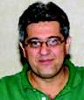Fuad G. Sobrinho, Ambiencia Information Systems
In addition to his role as president of Ambiencia Information Systems in Brazil, Dr. Fuad Sobrinho is CTO of LabP3, a Laboratory for Process Production Process Network, which developed P3Tech - a design and process technology for complex network systems, a cross platform development environment with process editing, modeling and simulation tools, interface construction tools and runtime classes that is used world-wide to deploy business solutions ranging
from stand-alone departmental applications to sophisticated, distributed applications designed to address enterprisewide problems. He is the founder and former president of the Executive of Board of Directors of International Institute on Systems Integration – IIISis, Campinas, Sao Paulo,
Brazil.
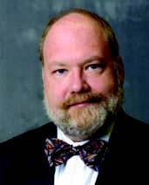Eugene H. Spafford, Purdue University
Eugene H. Spafford has worked in computing for three decades, the last 22 years at Purdue University. Best known for his work in information security, he has also worked on issues of software engineering, privacy, cybercrime, computing ethics and education. He will present a talk titled “Thinking Outside the Box.”

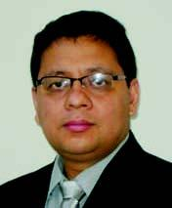James Joshi, University of Pittsburgh
James Joshi, associate professor in the School of Information Sciences at the University of Pittsburgh, is founder and the director of the Laboratory of Education and Research on Security Assured Information Systems, which has been designated jointly by the NSA and DHS as a National Center of Academic Excellence in Information Assurance Education & Research (CAE-R). His research interests include access control models, security and privacy of distributed multimedia systems, trust management and information survivability. He is a recipient of the NSF-CAREER award in 2006.
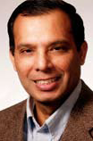Vir V. Phoha, Louisiana Technical University
Dr. Vir V. Phoha is a professor of computer science in the College of Engineering and Science at Louisiana Tech University in Ruston, LA. He holds the W. W. Chew Endowed Professorship at Louisiana Tech and directs the Center for Secure Cyberspace. He has won various distinctions, including ACM Distinguished Scientist, 2008; IEEE Region 5 Outstanding Engineering Educator Runner-Up award, 2008; research commemoration awards at Louisiana Tech University (2002, 2006, 2007, 2008); and outstanding research faculty and Faculty Circle of Excellence award at Northeastern State University, Oklahoma.

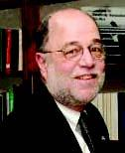Jay Fraser, Tracer Detection Technology Corp.
Jay Fraser is a technology entrepreneur with strategic planning, new business development, marketing and technology transfer and commercialization background. He has been involved in technology transfer from federal laboratories since 1990 and is the president of Tracer Detection
Technology Corp. Tracer was a spinout from his first technology transfer program. Today, the company is involved in document security, brand protection and, separately, covert tracking technologies. It is completing commercialization of its counterfeit detection solution and is performing on a contract extension from the Department of Defense to enhance its chemical track, trace and locate system.
Jim Brazell, Ventureramp
Jim Brazell is a technology forecaster, public speaker, group facilitator and technology and media strategist. His consulting and speaking topics include community competitiveness, educational innovation, emerging technology, emerging jobs and emerging creative communities. For the past five years, Jim has performed contract work for the Innovation, Creativity and Capital Institute at the University of Texas.

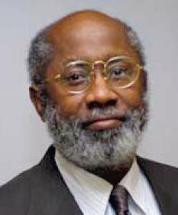Raymond A. Paul, Department of Defense
Raymond A. Paul serves in Command and Control Policy and manages trusted network enabled command and control systems engineering development in the Department of Defense. His current research focus is on high assurance systems engineering services, software engineering, dynamic environment decision framing and making with sensor networks. Paul holds a doctorate in software engineering and is an active fellow member of SDPS and IEEE Computer Society.

Sponsored by
Society for Design & Process Science (SDPS)
Software Engineering Society (SES)
Auburn University at Montgomery
GEMSAN-Istanbul-Turkey
Co-sponsored by

IC2 Institute, University of Texas
Intelligent Systems Technology Inc.
University of Alabama at Birmingham

